14.1: 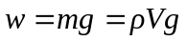
or 42 N to two places. A cart is not necessary.

